Sales Order
Time to order the New Ashland County 4-H T-shirt | August 2016

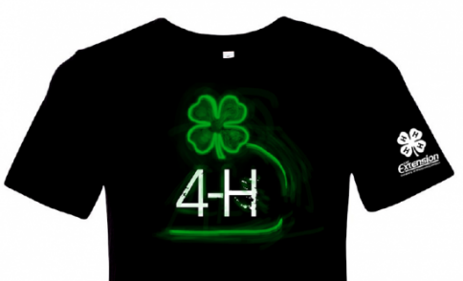
T-shirt orders are due to the UWEX office before Wed, August 17

The 4-H T-shirt design contest winner this spring was Colin Liphart and his design is featured on our new 2016 T-shirts. See ashland.uwex.edu/ for full image.
We will be placing our order with Heart Graphics on Wed, August 17th. The shirts are black, 100% cotton, with adult sizes (Small through XXXL) & youth sizes (Small through XL) available. The shirt features green and white graphics on the front and a small 4-H clover and UWEX logo on the sleeve.
T-shirts cost $10 each, orders will need to be paid before being picked up at the Ashland County UWEX office in late August. Questions or to order by phone call 715-682-7017.

4-H Club / Family Name: ____________________________

Name | Adult or Youth T-shirt Size | Phone # | Email
Cash or Checks - Make all checks payable to Ashland County 4-H

Return form before August 17, 2016 to:
UW-Extension Ashland County Office, 201 West Main Street, Courthouse, Room 107, Ashland, WI 54806
Doug Liphart, 4-H & Youth Development Educator, P 715-682-7017, F 715-682-7922, amy.tromberg@ces.uwex.edu

