Extension Ashland County Office
201 West Main Street
Courthouse, Room 107
Ashland, WI 54806-1652

Phone: (715) 682-7017

FAX: (715) 682-7922

October 2021

Dear 4-H'er in 8-12th grade,
On behalf of Ashland County 4-H, I'd like to invite you to submit a ME (Member Evaluation) and apply for a scholarship award to one of the programs offered through 4-H. Some of the programs are on hold for the 2021-2022 year due to the COVID pandemic, hopefully to resume in the 2022-2023 year (Arts, Space Camp). Many of the programs that were off the table for 2021 will be held again in 2022 (4-H State Youth Conference, Citizenship Washington Focus, International). Check the list on the application and the enclosed brochure to see what opportunities await you as an older 4-H member! Occasionally, a member becomes aware of other opportunities, and we encourage you to apply for them (please note the program in the "other" category).
ME’s are an opportunity and an honor that is only offered to older members. The application process will help prepare you to apply for schools, scholarships, and jobs. ME applications are available in paper format and on our website. The deadline for ME applications is October 21st by 3pm (ME interviews are on October 27th between 4pm and 6pm). We will be accepting applications, electronically, by mail, or you can drop them off at our office. If the office is not open please feel free to leave your completed paperwork in the basket on our door.
If you have any questions about the ME process, or award trips and programs, please feel free to contact your 4-H Club Leader or me. If you need help or have questions about filling out applications, your club leaders and I would be happy to help. On behalf of the Ashland County 4-H Parent Leader's Organization, we will look forward to seeing your application! We will accept ME’s with an additional informational page as a form of Record Book. Record Book check is scheduled for November 8th for those of you that participate.
For an electronic copy of the ME forms, Letter of Recommendation, and Record Book pages please see our website at: https://ashland.extension.wisc.edu/4-h-youth-development/forms/

Sincerely,

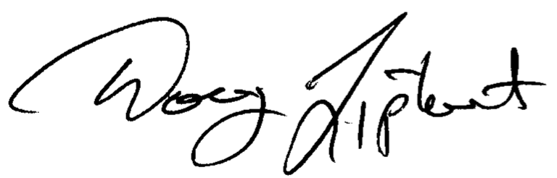

Doug Liphart
4-H and Youth Development Educator
doug.liphart@wisc.edu

