Hello 4-H member!

As a 4-Her, you do so many great things that are important to acknowledge! That is one reason why 4-H has a record keeping process – to make sure that youth remember their achievements, growth, and lessons for the future, and others can know, too! Experiential learning within 4-H programs helps the youth complete projects AND gain skills to use in life! The forms here are tools to express your experiences.
You can include…
- newspaper clippings,
- magazine images,
- catalog images,
- computer graphics,
- original drawings,
- other original art,
- flyers from clubs,
- event programs,
- samples of fabric,
- samples of yarn,
- and so on.
Contents of 4-H Member Record Book Forms (Choose What You Want!)

- A cover or folder of any color (you choose and decorate it!)
- Member Records Checklist (page 1)
- Month Reflections (pages 2-13)
  - These follow the 4-H year from October-September.
  - There is space to write short stories on events if you wish.
  - Feel free to add pages if needed.
- Project Story/Summary (page 14)
  - You can use different formats to share the story, like slides!
  - Ask your Club Leader or 4-H Educator any formatting questions.
- 4-H Life Skills Wheel (page 15) – optional reflection
Guidelines to Remember for Member Records

- Submit your record book on time!
  - By the club due date or the office due date
  - This year’s office due date: October 13, 2023 at 4PM
- Do not include physical awards (ribbons, plaques, trophies, etc.)
  - Pictures or other representations of awards are acceptable.
- Keep records safe to use later when completing ME or other forms!
- Talk with your Club Leaders or 4-H Educator if you have questions!
- Explore online for more ideas!
Looking forward to learning more about your
experiences and honoring your work in 4-H!
Thank you for doing the Record Book Process! If you have questions, please call Ashland County Extension at 715-682-7017, or contact the 4-H Youth Development Educator:
715-208-0664 | kate.wallner@wisc.edu | 201 Main St. W, Rm 107  Ashland, WI 54806 | http://ashland.extension.wisc.edu/

--- Member Records Checklist ---
For October 2022 - September 2023 |  |  | (Draw or attach a picture of yourself here!)
Current Date:

4-H Member Name:

Number of Years in 4-H
(including the year listed above):
Is this your 1st time doing Member Records?
(circle your answer): YES NO
If “No,” how many times have you done Records?
For Member Records Recognition,
choose your preferred reward (circle your choice):
DISC 4-H ITEM
TIME TO REMEMBER YOUR INVOLVEMENT & ACCOMPLISHMENTS!
List the 4-H Clubs you were enrolled in for the year and share the requested information.
4-H Club(s)  from the Past Year | Years Enrolled  In the Club(s) | Your Most Important or Favorite  Accomplishments in the Club(s)
List any club offices or leadership roles you had and share the requested information.
4-H  Club | Club Officer and/or  Leadership Role | Your Most Important or Favorite  Accomplishments in the Role(s)
List your projects that you were enrolled in for the year and share the requested information.
4-H  Project | Demonstration or  Project Talk | Your Most Important or Favorite  Accomplishments in the Project(s)

--- Month of October ---
Name & Date  of the Event | Event Details: weather conditions, tasks, and how things went!  (Please attach additional pages if needed!) | Ideas to Keep for Next Time
Photos and/or Drawings of the Events:

--- Month of November ---
Name & Date  of the Event | Event Details: weather conditions, tasks, and how things went!  (Please attach additional pages if needed!) | Ideas to Keep for Next Time
Photos and/or Drawings of the Events:

--- Month of December ---
Name & Date  of the Event | Event Details: weather conditions, tasks, and how things went!  (Please attach additional pages if needed!) | Ideas to Keep for Next Time
Photos and/or Drawings of the Events:

--- Month of January ---
Name & Date  of the Event | Event Details: weather conditions, tasks, and how things went!  (Please attach additional pages if needed!) | Ideas to Keep for Next Time
Photos and/or Drawings of the Events:

--- Month of February ---
Name & Date  of the Event | Event Details: weather conditions, tasks, and how things went!  (Please attach additional pages if needed!) | Ideas to Keep for Next Time
Photos and/or Drawings of the Events:

--- Month of March ---
Name & Date  of the Event | Event Details: weather conditions, tasks, and how things went!  (Please attach additional pages if needed!) | Ideas to Keep for Next Time
Photos and/or Drawings of the Events:

--- Month of April ---
Name & Date  of the Event | Event Details: weather conditions, tasks, and how things went!  (Please attach additional pages if needed!) | Ideas to Keep for Next Time
Photos and/or Drawings of the Events:

--- Month of May ---
Name & Date  of the Event | Event Details: weather conditions, tasks, and how things went!  (Please attach additional pages if needed!) | Ideas to Keep for Next Time
Photos and/or Drawings of the Events:

--- Month of June ---
Name & Date  of the Event | Event Details: weather conditions, tasks, and how things went!  (Please attach additional pages if needed!) | Ideas to Keep for Next Time
Photos and/or Drawings of the Events:

--- Month of July ---
Name & Date  of the Event | Event Details: weather conditions, tasks, and how things went!  (Please attach additional pages if needed!) | Ideas to Keep for Next Time
Photos and/or Drawings of the Events:

--- Month of August ---
Name & Date  of the Event | Event Details: weather conditions, tasks, and how things went!  (Please attach additional pages if needed!) | Ideas to Keep for Next Time
Photos and/or Drawings of the Events:

--- Month of September ---
Name & Date  of the Event | Event Details: weather conditions, tasks, and how things went!  (Please attach additional pages if needed!) | Ideas to Keep for Next Time
Photos and/or Drawings of the Events:

--- Project Story and/or Summary ---

Please describe what you learned in 4-H this year in 1-2 paragraphs!
Well done and thank you for sharing!

--- 4-H Life Skills Wheel ---
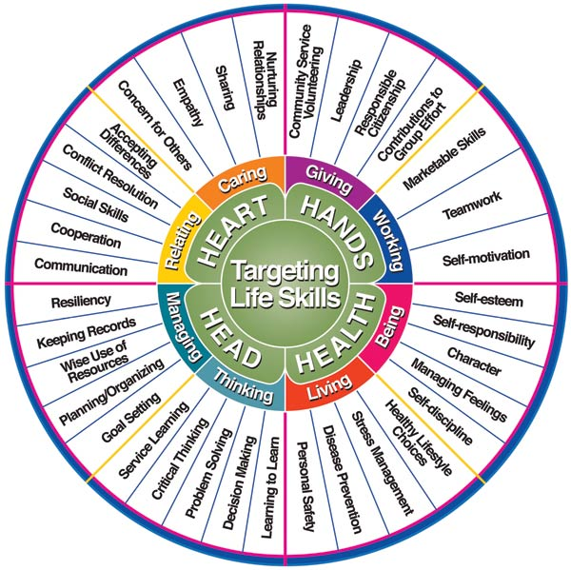 | The 4-H Life Skills Wheel (for more info, click here and/or here) shows how 4-H programs relate to lifelong growth. The 4 Hs connect to 8 skill categories:  - Head = managing & thinking  - Heart = relating & caring  - Hands = giving & working  - Health = living & being  The outer zone has 35 different skills within the 8 skill categories. After observing the skills wheel…  - First view or re-write your list of activities from this last year.  - Reflect on your feelings during each activity, and mark them on your list however you want or use the key:  Surprise Fun Challenge  Circle the activity Star the activity Underline the activity  - For each activity, identify at least 1 life skill you practiced during that experience, and write or connect the activity with the life skill.  - Review your marked up list and share what patterns you notice in your activities, skills, and growth!
Use the space below to write, draw, or map out the skills you practiced from your experiences this year.
Thank you for completing your reflection and participating in 4-H!
Please share your work with your club leader!

