This Spring’s Art Contest Theme is… Found Art!
Definition: Objects that are not originally designed for artistic purposes but can be used in artistic ways.
Check out these suggestions and links with examples to help brainstorm creative ideas for your artwork!
- Paint with home-made stamps from sponges, old cups, old cookie-cutters, paper towel rolls, potatoes, rags, etc.
- Mix materials to make different parts of your picture, like using an old hair comb to paint grass to create a landscape.
- Search “Found Art” online to learn more from videos like this: https://youtu.be/hhz1Vqx2UxA?si=t12XINcMhJJbEniL&t=3
Art Contest Process & Guidelines
The Spring Art Contest officially opens on Friday, March 15th, 2024.  - Canvases are ready to be picked up at the Ashland County Extension 4-H office.  - Some paint is available from the office for artist use, but supplies are limited.  - Artists are welcome to use their own materials or ask the office for assistance.  The Contest closes on Monday, April 29th for local panel of judges to review entries.  - Artwork entries are due by 4:00 pm to the Extension Office on the closing date.  - Remember to attach your entry form to the artwork (see info form below)!  - Artwork is reviewed based on 3 things: Creativity, Craftsmanship, & Comprehension.  After review, awards are announced at the 4-H Spring Art Celebration in early May!  - The event is held during the first weekend of May – event updates shared in April.  - Optional art activities are offered before awards are announced.  - All artwork entries are presented, and all participants receive a certificate.  - All winners in each age group (listed on the right) receive monetary awards. |  | AGE GROUPS  (7 Total)
5-6 years old
7-8 years old
9–10 years old
11–12 years old
13–14 years old
15–16 years old
17–19 years old
Important Notes to Keep in Mind!
 | Only one entry per artist is accepted and each artwork must be the individual artist’s original creation.
 | After the awards, artwork entries are publicly displayed on the 1st Floor of the Ashland County Courthouse.
 | Artists may collect their artwork and submit it to the Ashland County Junior Fair Exhibit held in August.
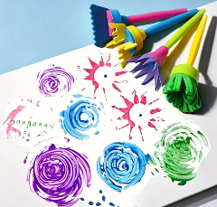
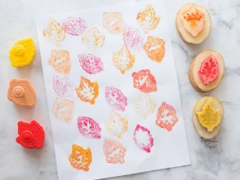

 |  | Cut here! - - - - - - - - - - - - - - - - - - - - - - - - - - - - - - - - - - - - - - - - - - - - - - - - - - - - - - - - - - - - - - - - - - - - - - - - - - - - - - - - - - -
SPRING 2024 ART CONTEST ENTRY FORM!
Instructions: Please fully complete the information below, then cut on the dotted line above. Securely tape this entry form to the back of the canvas without harming the artwork. Afterward, submit it to the Ashland County 4-H Extension Office.
 | Youth Artist’s First & Last Name: |  | Youth Artist’s Age:
 | Parent/Guardian Name & Phone #: |  | Title of Artwork:
 | Questions? Call the 4-H Office at 715-682-7017 or the 4-H Educator at 715-208-0664!

